Safe chain



University of Umm Al-Qura
College of Computing
Department of Computer Science

Proposal by
Authors:

Supervisors
Dr. Ali Alzubaidi
aakzubaidi@uqu.edu.sa

Content
Chapter1: Introduction 2
1.1 Introduction 3
1.2 The research problem 3
1.3 The purose of the project 3
1.4 Purpose of this Document 6
1.4.1 Reason for Creation: 6
1.4.2 Contents: 6
1.4.3 Audience: 6
1.4.4 Usage: 6
1.5 Existing System 6
1.5.1 Cooltrax-cold chain management and control system 6
1.5.2 DicksonOne-cloud-based environmental monitoring system 8
1.5.3 TempTale GEO Ultra-cold 10
1.5.4 Sonicu-cold chain monitoring system 12
1.5.5 shortcomings of the current systems versus the advantages of the proposed project 14
1.5.6 Comparison table between current systems and the proposed project 15
1.6 Methodology 16
1.6.1 Selected Methodology: Scrum (Agile) 16
1.6.2 Reasons for Selection 16
1.6.3 Objectives of Using Scrum 17
1.6.4 Comparison with Other Methodologies 17
1.6.5 Project Plan 18
1.6.6 Project Timeline Summary 20
1.6.7 Conclusion 21
1.7 Summery 21
Chapter2: SYSTEM ANALYSIS 22
2.1 Introduction 23
2.2 Stakeholders 23
2.2.1 Food transport and distribution companies: 23
2.2.2 Restaurants and food storage facilities: 23
2.2.3 Control bodies (such as the Food and Drug Authority): 23
2.2.4 Consumers: 23
2.3 Functional Requirements 23
2.3.1 User Login (FR_001): 24
2.3.2 Sensor Data Monitoring (FR_002): 26
2.3.3 Function 3 (FR_003): 26
2.4 Dependencies 27
2.5 None- Functional Requirements 27
2.5.1 Security 27
2.5.2 Privacy 27
2.5.3 Ease of Use 27
2.5.5 Performance 27
Requirements Modelling UML 28
Use Case Diagram 28
Sequence Diagram 28
Activity Diagram 29
Class Diagram 30
Summary 30
DESIGN CONSIDERATIONS 30
Introduction 31
Architectural Strategy 31
Presentation Layer (User Interface Layer): 31
Business Logic Layer (Processing and Notifications): 31
Data Layer (Storage and Synchronization): 31
Development Requirements 32
Hardware Requirements 32
Software Requirements 32
Graphic User Interface Design and wireframe 32
Summary 33
CONCLUISON 35
Introdction 35
Challenges and learning experiences 35
Timeline 36
Furture work 36
Conclusion 36
Reference: 37

List of figures
Figure 1 6
Figure 2 8
Figure 3 10
Figure 4 12

List ofTable
Table 1:Comparison with Other Methodologies 17
Table 2 Timeline & Weekly Activities: Phase 1 18
Table 3 Timeline & Weekly Activities: phase 2 19
Table 4 Project Timeline (Gantt style) 20
Table 5 Functional Requirement – User Login 24
Table 6 Functional Requirement – Sensor Data Monitoring 26

Abstract
This project, titled FoodSafe, aims to develop an intelligent system based on Internet of Things (IoT) technology to monitor and ensure food safety during transportation and storage. The proposed system integrates multiple environmental sensors to measure temperature, humidity, gas emissions (NH₃, CO₂, H₂S), and truck door status, providing real-time data to a central platform or mobile application.
The system utilizes a Raspberry Pi as the main controller, which collects and transmits sensor data to a cloud database for visualization and analysis. Through an intuitive dashboard, users can track live readings, receive instant alerts when conditions exceed predefined safety thresholds, and view historical reports summarizing key environmental trends.
The main objective of FoodSafe is to minimize food spoilage, enhance transparency in the cold supply chain, and support food safety and security by enabling immediate intervention when abnormal conditions occur. By offering a low-cost, user-friendly, and scalable solution, the system addresses major shortcomings of existing commercial systems, making it suitable for food transport companies, restaurants, and regulatory authorities.
Ultimately, FoodSafe contributes to reducing food waste, improving public health, and strengthening consumer confidence in food quality through smart monitoring and real-time control.

Chapter1: Introduction

1.1 Introduction
This project aims to develop a system based on the Internet of Things (IoT) to monitor and track food safety during transportation.
The system measures key factors such as temperature, humidity, and gas emissions inside the trucks, and then sends the data instantly to a simple platform or application to track it.
This project belongs to the field of Information Technology and the Internet of things with direct application in the food, transport and distribution sector.
The importance of the project lies in its role in ensuring the quality and safety of food, reducing spoilage and losses during transportation and storage, which supports food security and increases consumer confidence in food products.

1.2 The research problem
A Hungarian study published in the journal Foods in 2024 found that up to 30% to 50% of perishable food transported without proper temperature control can arrive at its destination spoiled or lost [1]. Upon further analysis of the underlying causes, one of the most critical issues identified in the food transportation chain is the failure to maintain proper temperature control, which significantly accelerates food spoilage.
Additionally, the lack of transparency in shipment tracking poses a major challenge, as many transportation systems lack accurate and real-time data regarding temperature and truck location. This makes it difficult to take timely action to prevent food deterioration.
Inspired by Islamic values that emphasize preserving blessings and valuing resources, this project aims to reduce food waste by designing a smart device equipped with sensors. This device is installed inside trucks to monitor temperature, humidity, and emitted gases, while also providing real-time tracking of location and internal conditions. The solution is intended to ensure better food preservation during transportation and reduce overall losses.

1.3 The purose of the project
1.3 Purpose of the Project
This project aims to develop a smart experimental system based on Internet of Things (IoT) technologies to monitor and track food safety during storage or transportation. The goal is to ensure food product quality, reduce the likelihood of spoilage, and support food security.
1.3.1 Main Objective of the Project
1.3.1.1 Develop a prototype that enables reading of basic data such as temperature, humidity, and gas emissions
• Temperature and humidity are among the most critical factors affecting food quality. According to the Food and Agriculture Organization (FAO), about 70% of refrigerated food spoilage is caused by uncontrolled fluctuations in temperature and humidity.
• The emission of gases such as ammonia (NH3) and hydrogen sulfide (H2S) serves as an early indicator of meat and dairy product spoilage.
• Therefore, this prototype provides a practical tool for accurately monitoring these indicators.
1.3.1.2 Transmit data in real-time to a simple platform or application for visualization
• Real-time monitoring reduces delays in problem detection.
• Studies in the field of cold chain monitoring show that delays in detecting temperature deviations may lead to losses of up to 35% of transported food products.
• Sending data directly to a platform or mobile application enhances responsiveness and immediate problem-solving.
1.3.1.3 Generate instant alerts when thresholds are exceeded
• Early alerts help in making timely decisions before losses occur.
• A study published in the Journal of Food Protection indicated that instant alert systems contributed to reducing refrigerated food losses by about 25%.
• This feature makes the system practical and economically valuable.
1.3.1.4 Test the system on a small-scale model to validate effectiveness
• Small-scale testing reduces risks and reveals errors before large-scale implementation.
• Prototypes are an essential step in developing any system, as they allow verification of hardware and software performance in a controlled environment.
• This increases the likelihood of success when scaling the project in the future.
1.3.2 Beneficiaries and Users
1.3.2.1 Food transport and distribution companies
• These companies face significant losses due to food spoilage during transportation.
• According to the World Bank, nearly 30% of food products worldwide are lost due to weak transport and storage systems.
• The proposed system helps these companies reduce losses through continuous monitoring.
1.3.2.2 Restaurants and food storage facilities
• Restaurants rely heavily on fresh ingredients, and their quality is directly tied to temperature and humidity conditions.
• Health reports indicate that one-third of food poisoning cases each year are linked to poor storage practices.
• By using the system, they can monitor inventory and protect customers from foodborne risks.
1.3.2.3 Regulatory authorities such as the Food and Drug Authority
• These authorities need accurate data to evaluate companies’ compliance with health standards.
• Traditional systems often rely on periodic manual inspections, while this system provides real-time and reliable data.
• This enhances regulatory efficiency and makes monitoring more proactive.
1.3.2.4 Consumers indirectly, by gaining access to safe products
• Consumers are the ultimate beneficiaries.
• The World Health Organization (WHO) reports that 600 million people fall ill every year due to contaminated food.
• Smart monitoring systems reduce the likelihood of unsafe products reaching consumers.
1.3.3 How the Project Helps Beneficiaries
1.3.3.1 Enable companies to monitor storage and transport conditions accurately and reduce losses
• The system provides companies with real-time intervention capability, which helps minimize financial losses caused by food spoilage.
1.3.3.2 Provide regulatory authorities with real-time and reliable data to support effective oversight
• Real-time data increases transparency and enhances authorities’ ability to make swift, informed decisions.
1.3.3.3 Enhance consumer confidence in the quality and safety of food products
• Smart monitoring systems build customer trust and provide companies with a competitive advantage in the market.
1.3.3.4 Support the community by reducing food waste and strengthening food security
• Reducing food waste directly contributes to global food security.
• According to the United Nations, about 14% of food is lost between harvest and retail, and this system can help reduce that percentage.

1.4 Purpose of this Document

1.4.1 Reason for Creation:
This document exists to outline the objectives, scope, and expected results of the smart food monitoring and tracking system project. It defines the purpose of the project and explains its importance in improving food quality, reducing waste, and supporting food safety.

1.4.2 Contents:
It contains details about the project goals, system functionalities, expected outcomes, and benefits. It also describes the technical and practical aspects of the prototype, as well as the target problems it aims to solve.

1.4.3 Audience:
The intended audience includes supervisors, academic instructors, project developers, stakeholders in the food supply chain, and regulatory authorities interested in food quality and safety.

1.4.4 Usage:
This document should be used as a reference throughout the project lifecycle. It guides the development process, supports evaluation and assessment, and provides a clear framework for understanding the project’s objectives, benefits, and applications.

1.5 Existing System
Currently, there are several systems and applications for monitoring food during transportation and storage, including intelligent refrigeration systems and heat and humidity sensors used in some major companies.

1.5.1 Cooltrax-cold chain management and control system

1.5.1.1 General description and mode of action
Cooltrax is an integrated system focused on monitoring refrigerated transport conditions and real-time Cold Chain Management. It offers a “Fresh InTransit " solution that allows monitoring trucks and refrigerated containers during their movement through wireless sensors connected to a communication module (Gateway) connected to a GPS tracking system. The system collects accurate temperature data inside the truck or container and sends it to the Cooltrax cloud servers. Users can follow the status of shipments moment by moment via a web dashboard or through phone applications. In addition, the system enables the creation of automated reports that support compliance with food safety standards such as HACCP and international regulations (As shown Figure 1 , Illustrates the application logo ).
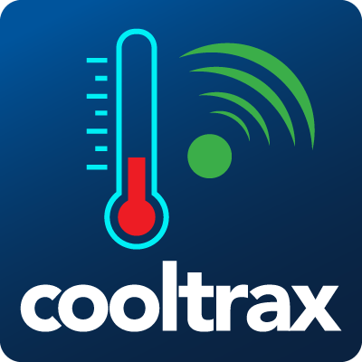
(Figure 1: Cooltrax-cold chain management and control system)

1.5.1.2 Basic Techniques and Components
1.5.1.2.1 Wireless Temperature Sensors:
Installed inside the refrigerated truck or container to measure and record temperature data precisely. Multiple sensors may be used to cover all internal areas and detect uneven cooling.
1.5.1.2.2 Gateway (Communication Module):
Collects data from sensors and pairs it with GPS signals. It timestamps the data and transmits it to the cloud via Wi-Fi or 4G networks.
1.5.1.2.3 GPS Tracking System:
Provides real-time location information of the vehicle. Combining temperature data with GPS coordinates helps identify where and when a temperature deviation occurs.
1.5.1.2.4 Cloud Platform (Cooltrax Cloud):
Responsible for receiving, analyzing, and securely storing all collected data. It provides dashboards, alerts, and downloadable reports.
1.5.1.2.5 Dashboard and Mobile Applications:
Offers visualized graphs, historical data, and color-coded alerts. The dashboard helps users easily interpret trends and respond quickly to abnormalities.
1.5.1.2.6 ERP/TMS Integration:
Allows Cooltrax to synchronize with Enterprise Resource Planning or Transport Management Systems for broader logistics control and operational automation.
1.5.1.3 Common Areas of use
The Cooltrax cold chain management and control system operates through an integrated process that ensures continuous monitoring and precise control of temperature-sensitive goods throughout the supply chain.
The system workflow can be summarized as follows:
- Installation of Devices:
Wireless temperature sensors and GPS-enabled tracking modules are installed inside refrigerated trucks, containers, or storage units to monitor environmental conditions in real time.
- Configuration of Parameters:
Users define acceptable thresholds for each variable (such as minimum and maximum temperature levels) according to the type of product being transported or stored.
- Data Collection and Transmission:
The sensors continuously measure temperature and humidity levels. These readings are transmitted via the communication gateway to the Cooltrax cloud platform using Wi-Fi or 4G networks.
- Data Visualization and Monitoring:
The collected data is displayed instantly on the Cooltrax dashboard and mobile applications. Users can view live readings, analyze graphical trends, and detect irregular patterns in the system performance.
- Alert Management:
If any value exceeds the pre-set limits, the system automatically generates instant alerts via e-mail or SMS, allowing users to respond quickly to prevent product spoilage or safety violations.
- Data Storage and Analysis:
All collected data is securely stored in the Cooltrax cloud database. Authorized users can access historical records, generate analytical reports, and review environmental trends to ensure long-term compliance and quality control.

1.5.1.4 Strengths
1. Integration of Environmental and Location Data:
Cooltrax combines GPS and temperature readings, providing both “where” and “what happened.”
This allows rapid root-cause analysis (e.g., identifying that a rise in temperature occurred at a specific stop) and increases transparency and trust with customers and authorities.
2. Global Real-Time Monitoring:
Through its cloud-based infrastructure, users can access shipment data anytime and anywhere.
This enables centralized monitoring and quick responses to abnormalities in large-scale logistics.
3. Automated Compliance Reporting:
Generates HACCP-ready reports automatically, saving time on manual documentation and ensuring continuous compliance with international standards.
4. Instant Multi-Channel Alerts:
When temperature thresholds are exceeded, the system sends immediate alerts via email or SMS, shortening response times and preventing product loss.
5. Interoperability with Other Systems:
The system integrates with ERP or TMS software, ensuring smooth data sharing and improving operational efficiency.
6. Customer Confidence:
By providing transparent and verified data on shipment conditions, Cooltrax helps companies build long-term credibility and enhance client satisfaction.
1.5.1.5 Weaknesses
1. Limited Scope (Temperature Focus Only):
Cooltrax only monitors temperature and does not detect other spoilage indicators such as humidity or gases (NH₃, CO₂, H₂S). This limitation reduces its ability to identify early stages of food spoilage.
2. High Initial and Operating Costs:
The system’s use of GPS, cloud subscriptions, and advanced sensors makes it costly for small and medium enterprises.
3. Dependence on Network Coverage:
Requires strong and continuous internet connectivity (Wi-Fi or cellular). In remote or cross-border areas, data loss may occur, reducing reliability.
4. Operational Complexity for Small Businesses:
Its advanced functions (like ERP integration) may be unnecessary or difficult to manage for small operators.
5. Low Flexibility in Customization:
Companies may find it difficult to adapt the system’s setup or interface for specific needs since it is built for large-scale operations.
1.5.1.6 Brief Analysis
Cooltrax is one of the most recognized systems in refrigerated transport monitoring, integrating temperature and GPS tracking for precise visibility and control.
It is ideal for large enterprises that require compliance, reliability, and international-level performance.
However, its focus on temperature only, high cost, and complex setup make it less suitable for small to mid-size businesses.
In contrast, our proposed system SafeChain builds upon Cooltrax’s strengths while addressing its limitations:
it adds gas and humidity sensors to detect spoilage earlier, uses low-cost IoT-based components (ESP32) for affordability,
and employs flexible communication options (Wi-Fi, 4G, LoRa) for wider coverage, while focusing on simplicity and ease of use.
The following table presents a clear comparison between Cooltrax and the proposed SafeChain system, highlighting their similarities and differences in functionality, technology, and cost-effectiveness.
Aspect | Cooltrax | SafeChain (Our Project)
Purpose | Real-time monitoring of refrigerated transport | Comprehensive monitoring with early spoilage detection
Sensors | Temperature only | Temperature + Humidity + Gas (NH₃, CO₂, H₂S) + Door sensor
Tracking | Built-in GPS | Optional GPS integrated with IoT module
Connectivity | Wi-Fi / 4G Cloud | Wi-Fi / 4G / LoRa + Cloud
Alerts | Email and SMS | App notifications + SMS + real-time alerts
Reports | Automated HACCP reports | Customizable, simplified reports
Cost | High (hardware + subscription) | Low-cost and locally implementable
Ease of Use | Complex, enterprise-focused | Simple, user-friendly, adaptable

1.5.2 DicksonOne-cloud-based environmental monitoring system

1.5.2.1 General description and mode of action
DicksonOne is an integrated cloud-based system used to monitor environmental conditions (especially temperature and humidity) in sensitive environments such as hospitals, laboratories, food warehouses, and pharmaceutical industries. Based on data loggers connected to the internet via Wi-Fi or Ethernet, these devices continuously collect data and send it to a centralized cloud platform. Through this platform, users can view real-time readings, retrieve historical data, and adjust the settings of alerts and reports. The system also provides multi-user access, which allows administrative and technical teams to work simultaneously (As shown Figure 2 , Illustrates the application logo ).
.
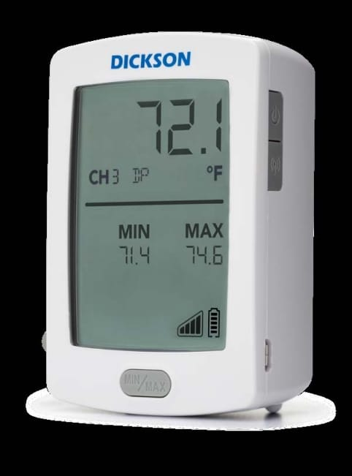
(Figure 2 , DicksonOne-cloud-based environmental monitoring)

1.5.2.2 Basic techniques and components
1.5.2.2.1 Sensors:
Sensors are the key element of the system, continuously measuring environmental values such as temperature and humidity. DicksonOne sensors are characterized by high accuracy and the possibility of calibration according to international standards such as NIST or ISO/IEC 17025 to ensure the reliability of readings.
1.5.2.2.2 Data Loggers:
These devices are used to receive and temporarily store sensor data before sending it to the cloud system. They have a backup internal memory to store data when the internet connection is interrupted, in addition to an internal battery that ensures continued operation in the event of a power outage.
1.5.2.2.3 Network Connectivity
The system supports several connection methods to facilitate connecting devices to the cloud:
- Wi-Fi for indoor environments.
- Ethernet for fixed networks, which is highly reliable.
- LoRaWAN for remote places or those with limited coverage.
- Bluetooth in some devices for quick setup purposes.
This flexibility in communication makes the system applicable in different environments, both small and distributed over several sites.
1.5.2.2.4 Cloud Platform
The cloud platform is the central heart of the system. It stores all the data sent from the sensors, from which the analysis, monitoring, and alarm management processes are managed. Users can access it via an interactive web interface (Web Dashboard) without the need to install any local software. There are also companion applications for smartphones that provide a simplified view of data and instant alerts, but they are not the platform itself (As shown Figure 3 , interactive web interface)
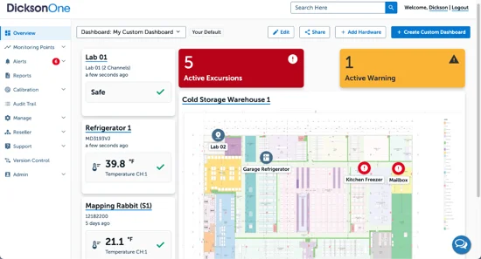

(Figure 3 , interactive web in DicksonOne)

1.5.2.2.5 Alert System
DicksonOne allows you to create custom alerts for each environmental variable. When the temperature or humidity exceeds the set values, the system sends instant notifications via e-mail, text messages, or phone notifications. This feature reduces the likelihood of damage to products or loss of samples due to sudden environmental changes.
1.5.2.2.6 Reporting and Analysis:
The system enables the creation of periodic or on-demand reports that include historical data, graphs, and time trends. Reports can also be exported in multiple formats (PDF, Excel) to meet the requirements of internal audits or regulatory authorities.

1.5.2.3 common Areas of Use
1. Sensors and recording devices are installed in the required locations such as cold rooms or laboratories.
2. Sets the allowable thresholds for each variable (e.g. maximum and minimum temperature).
3. Recording devices periodically send data to the cloud platform via the internet.
4. The readings in the dashboard are displayed instantaneously and can be tracked graphically.
5. If any value exceeds the specified limits, the system issues instant alerts.
6. The data is stored in a secure cloud database that allows historical records to be consulted when needed.

1.5.2.4 Security and System Integration in DicksonOne:
The DicksonOne system emphasizes the importance of security and controlled system integration due to the sensitivity of the data it handles, including medical and food-related information. The system is designed following a multi-layer security approach (Defense in Depth) to protect data during transmission, storage, and access. Additionally, it provides limited but structured methods to integrate with external systems.
1.5.2.4.1 Data Encryption in Transit:
All data transmitted from sensors to the cloud platform is encrypted using SSL/TLS protocols. This prevents unauthorized interception and ensures secure communication across the network.
1.5.2.4.2 Data Encryption at Rest:
Data stored on DicksonOne cloud servers is encrypted with strong algorithms such as AES-256. Even in the event of unauthorized physical access to servers, data cannot be read without encryption keys.
1.5.2.4.3 User Access Control:
The system uses role-based access control (RBAC), assigning each user permissions according to their role. Passwords are encrypted and cannot be viewed by any user.
1.5.2.4.4 Audit Trail:
All user activities, including logins, data modifications, and system changes, are automatically logged. These records are immutable and support security audits and investigations.
1.5.2.4.5 Regulatory Compliance
DicksonOne complies with standards such as FDA 21 CFR Part 11 and GxP, ensuring data integrity and suitability for pharmaceutical and food industries.
1.5.2.4.6 Data Backup and Recovery
Automatic backups are performed across multiple geographic locations (redundant data centers), allowing seamless data recovery in case of server failures.
1.5.2.4.7 Secure Authentication
The system supports two-factor authentication (2FA) and strong password policies, including complexity requirements and periodic updates.
1.5.2.4.8 Security Monitoring
Continuous monitoring detects abnormal activities, such as failed logins or unexpected configuration changes, ensuring proactive threat management.

1.5.2.4 Strengths
1.5.2.4.1 integrated cloud system
The fact that the system is cloud-based means that the user can access data from anywhere and at any time, without the need for local storage or maintenance of internal servers.
1.5.2.4.2 high flexibility of communication
The system supports more than one communication protocol (Wi-Fi, Ethernet, LoRaWAN), which makes it applicable in different environments in terms of infrastructure.
1.5.2.4.3 instant monitoring and smart alerts
The system is characterized by its ability to send instant notifications when any deviation in the readings occurs, which ensures a quick response and minimizes losses.
1.2.5. 4.4 compliance with international standards
The system is compliant with FDA 21 CFR Part 11 data integrity requirements, making it suitable for controlled medical and industrial facilities.
1.2.5.4.5 scalability (scalability)
The system can be started using a limited number of devices, and later expanded to several sites or branches without the need for radical changes in the architecture. 4.6 advanced reporting and analysis It provides sophisticated graphical analysis tools that help track environmental performance and detect long-term trends or recurring problems. 4.7 security and user management The system has a tiered permissions system that determines who can access data or modify settings, with an Audit Trail to track any changes. 4.8 backup storage and data loss protection The data is kept in cloud servers with periodic backups, as well as local memory inside the devices that protects against information loss when the connection is interrupted.

1.5.2.5 Weaknesses and challenges

1.5.2.5.1 full dependence on internet connection
The system is based on data transfer to the cloud, which means that any interruption in the internet may delay updates or alerts. Although some devices have local memory, an immediate alert may not be sent until the connection is returned.
1.5.2.5.2 subscription and hardware cost
High-resolution hardware and cloud service licenses require a relatively high physical cost, which can be a burden for small or budget-limited projects.
1.5.2.5.3 cyber security challenges
The fact that the system is connected to the cloud makes it vulnerable – like any other networked system – to possible cyber attacks if it is not adequately secured. This requires constant security updates, the application of strict access policies.
1.5.2.5.4 the need for periodic calibration of sensors
Over time, the sensors may lose their accuracy due to environmental factors, which requires regular calibration to ensure the reliability of the recorded data.
1.5.2.5.5 alarm delay in some cases
When setting sampling intervals (Sampling Interval) over long time intervals, a noticeable delay may occur between the actual occurrence of the change in values and the reception of the alarm in the system.
1.5.2.5.6 complexity of setup in large networks
If the system is applied to multiple installations or different geographical locations, careful management of settings and distribution of permissions may be required to avoid data conflicts or operational errors.
1.5.2.5.7 challenges in integration with other systems
Despite the existence of a software interface (API), the system faces limitations that limit the flexibility of integration, such as limited access to some types of data, the absence of real-time integration, the absence of Webhooks, as well as the absence of support for standard industrial protocols such as Modbus and MQTT, which makes it difficult to integrate the system in advanced industrial environments.

1.5.2.6 Brief summary of the DicksonOne system
The DicksonOne system is a reliable cloud solution for monitoring temperature and humidity in sensitive environments such as hospitals, laboratories and the pharmaceutical industry. It features accurate measurement, instant alerts, and accessibility from anywhere. But the system is focused only on limited environmental factors, and is completely dependent on the internet connection, which can cause a delay in alerts when interrupted. Subscription and hardware costs may also be high for some. Integration with industrial plant management systems is limited due to the lack of support for common industrial protocols, which limits the capabilities of automatic control.

1.5.3 TempTale GEO Ultra-cold

1.5.3.1 General description and mode of action
TempTale GEO Ultra is an integrated real-time Cold Chain Monitoring and management system, widely used in the food and pharmaceutical industries. Developed by Sensitech, it combines advanced sensors, GPS tracking technology and a global network connection (GSM/4G LTE), allowing users to track their shipments during transportation anywhere in the world. The system works via smart data recorders placed with products inside trucks or refrigerated containers, these devices collect accurate data about temperature, humidity and geographical location, and then send it instantly to a centralized cloud platform. This platform enables users to track shipments moment by moment, and receive instant notifications in case of exceeding the allowed limits or any malfunction during the trip.
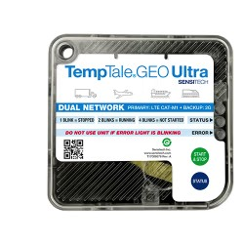
Figure 3

1.5.3.2 Basic techniques and components
1. Advanced data loggers (Data Loggers): measure temperature, humidity, and geographical location.
2. Built-in GPS technology: to accurately determine the location in real time.
3. Universal cellular connection (GSM/4G LTE): ensures data transmission from almost any network coverage area.
4. Centralized cloud platform (ColdStream Platform): receives and displays data via an easy-to-use interface.
Instant multi-channel alerts: via email, text messages, or platform notifications. 5.
6. Automatic reports: can be used to demonstrate compliance with standards such as FDA and GDP (Good Distribution Practice).

1.5.3.3 Common areas of use
TempTale GEO Ultra is mainly used in the transportation of heat-sensitive products, such as medicines, vaccines, and fresh food products. Major logistics companies rely on it to ensure the safety of their products during global distribution, especially when dealing with long distances or shipments need very precise conditions. It is also used in the agricultural and food industries to track products from farms to stores, enhancing transparency in the supply chain.

1.5.3.4 Strengths
1. Comprehensive real-time monitoring: combines temperature, humidity and location data, giving a complete view of the shipment.
2. Global tracking capability: thanks to cellular connectivity and GPS technology, cross-border shipments can be easily tracked.
3. Proactive alerts: helps users to intervene quickly in the event of a malfunction, minimizing losses.
Accurate compliance reports: facilitates the passage of audits from regulatory authorities. 4.
5. The possibility of managing several shipments at once: the cloud platform is designed to support large-scale operations.
6. Strong reputation in the market: being a product of Sensitech, a global company specializing in this field.

1.5.3.5 Weaknesses
1. High cost: devices are expensive and require annual or monthly subscriptions to the cloud platform.
2. High dependence on the cellular network: in areas where GSM/4G coverage is not available, data transmission may be delayed.
3. Complexity in initial operation: the user needs basic training to manage the system and take full advantage of its capabilities.
4. A basic focus on heat and humidity: although the system is accurate, it does not cover additional factors such as the emission of gases that may indicate the onset of food spoilage.
5. Hardware size: some sensor modules may be larger than required for small or sensitive shipments.

1.5.3.6 Brief analysis

TempTale GEO Ultra is one of the most powerful commercial systems in tracking refrigerated shipments globally, and is an ideal option for large companies with huge budgets and dealing with large-scale distribution. However, it mainly focuses on temperature, humidity and geographical location, and does not touch on other factors such as gases (NH3, CO2, H2S) that are an early indicator of food spoilage. In addition, the high cost makes this system unsuitable for small and medium-sized businesses. Here your proposed project has the advantage of being low-cost, more flexible, combining heat, humidity and gas monitoring with real-time notifications via a simple application, which makes it a practical and effective solution for a wider segment of users.

1.5.4 Sonicu-cold chain monitoring system

1.5.4.1 General description and mode of action
The SoniShield Duo by Sonicu is an advanced wireless environmental monitoring system designed to accurately measure, record, and analyze critical environmental parameters in real time.
The system operates through two NIST-certified digital sensors connected to the main monitoring unit, continuously collecting data on temperature, humidity, air flow, and door activity.
This data is temporarily stored in the device’s internal memory and then automatically transmitted via wireless network to the SoniCloud platform, which performs analysis, report generation, and real-time alerting when any threshold is exceeded.

The system also supports integration with other facility management or monitoring systems (e.g., hospital or laboratory networks) using standard communication protocols such as HTTPS and MQTT.
This enables seamless data exchange between devices and platforms, allowing unified environmental monitoring across multiple locations.
Thus, SoniShield Duo functions as part of an interconnected digital ecosystem, enhancing both operational efficiency and monitoring accuracy.
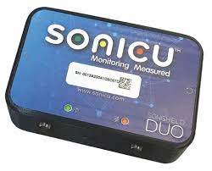
Figure 4

1.5.4.2 Basic techniques and components
1.5.4.2.1Sensors:
High-accuracy NIST-certified digital sensors for temperature and humidity with fast response and long-term stability.
1.5.4.2.2 Connectivity Module:
Supports Wi-Fi, Ethernet, or LoRa with strong data encryption to ensure security during transmission.
1.5.4.2.3Storage and Power:
Built-in memory for local data storage during network outages, and an internal backup battery for uninterrupted operation.
1.5.4.2.4 Cloud Platform:
SoniCloud handles data processing, storage, analytics, and visualization through a user-friendly online dashboard.
1.5.4.2.5Software Integration:
Offers limited integration with other systems through restricted APIs; software customization or adding new sensors is not allowed.
1.5.4.2.6User Interface:
Allows real-time and historical data access, customizable alerts (email, SMS, or push), and report generation.

1.5.4.3 Common areas of use
The SoniShield Duo is used across multiple sectors that require precise environmental monitoring ,including:
1. Hospitals, operating rooms, and medical laboratories.
Pharmacies, drug storage facilities, and cold chain warehouses. 2.
Restaurants, industrial kitchens, and food logistics. 3.
4. Museums and archives for sensitive material preservation.
Research centers and university laboratories. 5.

1.5.4.4 Strengths
1. High Measurement Accuracy: NIST-certified sensors provide reliable and precise environmental readings suitable for sensitive conditions.
2. Operational Continuity: Backup battery and internal memory ensure data collection even during power or network failures.
3. Integrated Cloud Platform: SoniCloud offers real-time data tracking, automatic analysis, and regulatory-compliant reporting.
4. Multi-Channel Alerts: Supports alerts via email, SMS, phone calls, or push notifications, minimizing response time in emergencies.
5. System Integration: Compatible with enterprise-level facility systems using modern communication protocols, enabling smooth interoperability.
6. User-Friendly Interface: Provides quick data access and analysis tools for technicians and administrators without requiring deep technical expertise.

1.5.4.5 Weaknesses
1. Lack of Gas Detection: Does not include gas sensors (e.g., NH₃, H₂S), which are important for detecting food spoilage.
2. High Cloud Dependency: Relies heavily on the SoniCloud server connection; data delays may occur if internet access is unstable.
3. High Cost: Designed primarily for healthcare and laboratory environments, making it more expensive than simpler or open-source solutions.
4. Limited Customization: The system is closed-source, preventing modifications or the addition of new hardware modules.
6. Restricted External Integration: Although it supports certain protocols, full interoperability with other systems requires vendor support.

1.5.4.6 Brief analysis
The SoniShield Duo demonstrates several valuable design principles that can be applied to the SafeChain project, as it ensures reliable operation with continuous monitoring even during outages, provides a secure cloud-based system for data collection and analysis, and utilizes smart multi-channel alert management to maintain efficiency and safety.
However, the SafeChain project expands on these concepts by introducing additional innovations, including gas sensors (NH₃ and H₂S) for early detection of food spoilage, which adds an advanced layer of preventive monitoring. It also features a fully open and integrable architecture using APIs and Webhooks, enabling seamless communication with any external system. In addition, SafeChain employs smart power management and encrypted local storage to ensure data security and uninterrupted operation, with scalable options that include a low-cost research edition and a full commercial version.
In conclusion, SafeChain combines precision, autonomy, and interoperability to deliver a customized and efficient food-safety monitoring solution, while SoniShield Duo remains ideal for clinical and laboratory environments.

Comparison: SoniShield Duo vs SafeChain
Feature / Aspect | SoniShield Duo | SafeChain
Operation Reliability | Reliable operation and continuous monitoring even during outages | Reliable operation with smart power management for uninterrupted operation
Data Collection & Security | Secure cloud-based data collection and analysis | Secure cloud + encrypted local storage
Alerts Management | Smart multi-channel alert management | Smart multi-channel alert management
Sensors | Standard sensors for clinical/lab environment | Includes gas sensors (NH₃ and H₂S) for early food spoilage detection
Integration | Limited to built-in systems | Fully open architecture with APIs and Webhooks for seamless integration with external systems
Scalability / Versions | Single optimized version for lab/clinical use | Scalable versions: low-cost research edition and full commercial release
Target Environment | Clinical and laboratory environments | Customized food-safety monitoring with precision, autonomy, and interoperability

1.5.5 shortcomings of the current systems versus the advantages of the proposed project

1.5.5.1 cost factor
The problem: most of the current systems are expensive, both in terms of the price of devices and monthly subscription fees to cloud platforms, making them difficult to access for companies with limited budgets or in developing countries.
The solution in our project: providing a low-cost solution based on available commercial sensors and open source platforms, which reduces the overall cost and makes the system available to a wider segment of users.

1.5.5.2 comprehensiveness of follow-up
The problem: most systems are limited to monitoring only temperature and humidity, while some systems such as TempTale GEO Ultra add geo-tracking, which makes their ability to detect problems early limited.
The solution in our project: the system integrates a wide range of sensors that cover several basic aspects of cold chain monitoring, namely:

Sensitive to temperature and humidity: to strictly follow the storage and transportation conditions.
Door sensor: to detect any unauthorized opening of the door, which contributes to the Prevention of theft or the ingress of external pollutants such as dust or unclean air.
Geographic tracking (GPS): to track the location of the truck in real time and document its route.
Gas sensors (NH3, CO2, H2S): for early detection of food spoilage by monitoring the emission of biogas.
This integration makes the system more comprehensive and integrated compared to commercial systems, gives it a predictive and proactive ability to protect food products and ensure their safety during transportation and storage.

1.5.5.3 ease of Use and integration
Problem: many systems are oriented to large companies and require special training or technical experience for operation and management. Also, some of them mainly rely on email or periodic reports for alerting.
The solution in our project: to present a simple and easy-to-use application that works on smartphones or the web, with instant alerts sent via notifications, making the response faster and more practical.

1.5.5.5 contribute to food security and reduce losses
The problem: trading systems are often focused on achieving compliance and increasing the profits of large companies.
The solution in our project: focuses on serving the wider community by reducing food waste, enhancing food security, and increasing consumer confidence in products.

1.5.5.6 conclusion
It can be said that our project not only aims to imitate existing systems, but also seeks to fill their gaps by providing an integrated solution that combines: low cost, comprehensiveness of measurements (temperature, humidity, door, tracking, gases), ease of Use, and future flexibility, making it a more effective and sustainable option for different categories of users.

1.5.6 Comparison table between current systems and the proposed project

Ease of use | Weaknesses | Strengths | General description | System / project
Medium (requires technical experience and training) | 1.The cost of periodic subscriptions  2.Dependence on the internet connection  3.Limited customization | 1. Integration of environmental monitoring with geographic tracking.  2. Real-time global followup.  3.Instant alerts. | An integrated system for monitoring refrigerated transport conditions and real-time Cold Chain Management, based on wireless sensors + GPS + cloud platform. | Cooltrax
Relatively easy | 1.Ongoing subscription fees.  2.It depends on the network.  3.Limited in customization. | 1.Flexible and cloud platform.  2.Multi-channel alerts.  3.Long data history. | A cloud system for monitoring temperature and humidity via data Loggers connected to the Internet (Wi-Fi/Ethernet). | DicksonOne
Medium (requires preparation and training) | 1.Depends on cellular coverage.  2.He needs preliminary training.  3.The size of the devices is relatively large. | 1.Comprehensive monitoring (temperature, humidity, location).  2.Global tracking.  3.Manage several shipments together. | Real-time Cold Chain Monitoring and management system with GPS + GSM/4G LTE + cloud platform. | TempTale GEO Ultra
Medium (preparation and operation requires experience) | 1.High initial and operational cost.  2.Limited customization.  3.Cost of maintenance/batteries. | 1.Real-time and reliable monitoring.  2.Flexible connection (cellular/Wi-Fi/radio).  3.Specialized solutions for refrigeration/ammonia. | An integrated system for monitoring heat, humidity and some ammonia leaks via the SoniCloud cloud + mobile app. | Sonicu
Very high (simplified and easy-to-use application) | 1.A project is under development.  2.Need extensive field tests. | 1.Low cost.  2.Collects heat + moisture + gases (NH3, CO2, H2S) + the state of opening/closing doors.  3.Simplified and easy application. | A low-cost solution based on commercial sensors and open source platforms + an easy-to-use mobile/web application. | project
Observation:
It should be noted that the current comparison reflects the basic characteristics of the most common systems, however, some companies may introduce upgraded versions or models that include additional advantages such as wider measurements or advanced technical integrations. These versions are usually aimed at groups with special needs and come at a higher cost compared to the basic platforms.

1.6 Methodology
1.6.1 Selected Methodology: Scrum (Agile)
The project will adopt the Scrum (Agile) methodology, which is one of the most widely used iterative and incremental software development approaches. It emphasizes flexibility, continuous improvement, and delivering functional prototypes in short cycles (sprints).

1.6.2 Reasons for Selection
- Flexibility in dealing with hardware and software integration
  - The project combines sensors (hardware) with IoT platforms and a mobile/web application (software). Agile allows step-by-step testing of each component and smooth integration.
- Incremental delivery of a working prototype
  - The ability to test and validate a small-scale version before large-scale deployment reduces risks and ensures higher success.
- Rapid response to changes
  - Since the project may face unexpected issues (sensor calibration, connectivity problems, or application design adjustments), Agile allows continuous updates without disrupting the entire plan.
- Stakeholder engagement
  - Regular sprint reviews and demonstrations allow food industry stakeholders, supervisors, and academic instructors to provide feedback early.
- Support for future expansion
  - Agile makes it easier to integrate predictive analytics and AI in later phases without redesigning the entire system.

1.6.3 Objectives of Using Scrum
- To ensure that the system is developed iteratively, minimizing risks.
- To guarantee that user requirements (food companies, restaurants, regulators) are continuously considered and validated.
- To allow prototyping and testing of sensors, mobile application, and cloud integration at each sprint stage.
- To achieve a balance between time, cost, and quality while maintaining transparency and traceability of progress.

1.6.4 Comparison with Other Methodologies
Methodology | Strengths | Weaknesses | Suitability for This Project
Waterfall | Clear stages, structured, good for fixed requirements | Rigid, hard to adapt if requirements change, testing comes late | Not suitable because IoT projects need frequent testing and adjustments
Agile (Scrum) | Flexible, iterative, frequent feedback, supports hardware+software integration | Requires active collaboration and discipline | Most suitable because the project involves experimental prototypes, feedback, and gradual improvements
Table 1:Comparison with Other Methodologies

1.6.5 Project Plan
The FoodSafe project is aimed at developing an intelligent food safety monitoring system using IoT sensors, cloud integration, and mobile applications. The project will be executed over 10 months (40 weeks), divided into 20 sprints of 2 weeks each. Each sprint delivers a functional increment that can be tested and validated.
The plan is structured into six main phases, each addressing critical components of the system: hardware (sensors + Raspberry Pi), software (dashboard and mobile app), and cloud integration.
- Phase 1: Preparation & Setup (Sprint 1–2, Month 1)
Week | Dates | Activities | Objective / Deliverable
Week 2 | 31/08/2025 – 04/09/2025 | Team formation, brainstorm project ideas, initial supervisor meeting, assign roles | Organize team and define roles
Week 3 | 07/09/2025 – 11/09/2025 | Refine project idea, ensure feasibility, start progress tracking | Confirm feasibility and progress system setup
Week 4 | 14/09/2025 – 18/09/2025 | Finalize project idea and roles, draft initial project plan, get supervisor feedback | Approved initial project plan
Table 2 Timeline & Weekly Activities: Phase 1

Activities:
- Set up development environment (IDE, GitHub repository, Trello board).
- Install and configure databases (Firebase/MongoDB).
- Connect and calibrate temperature & humidity sensors using Raspberry Pi.
- Define system requirements and assign tasks to team members.
Deliverable:
- Initial development setup + working sensor prototype.
Raspberry Pi Role:
- Central controller for sensor data acquisition and initial processing.
- Chosen for low cost, ease of IoT integration, Python/Node.js support, and rapid prototyping.

- Phase 2: Basic Monitoring System (Sprint 3–6, Months 2–3)
Week | Dates | Activities | Deliverable
Week 5 | 21/09/2025 – 25/09/2025 | Define problem statement, objectives, outcomes, select development methodology, get supervisor feedback | Clear project scope and methodology
Week 6 | 28/09/2025 – 02/10/2025 | Literature review and project uniqueness analysis | Ensure originality and research grounding
Week 7 | 05/10/2025 – 09/10/2025 | Submit Chapter 1 draft; begin research and gather requirements (Chapter 2) | Chapter 1 submission & initial requirements collection
Week 8 | 12/10/2025 – 16/10/2025 | Continue research and gather requirements (Chapter 2) | Complete initial requirements collection
Table 3 Timeline & Weekly Activities: phase 2
Activities:
- Connect sensors to MQTT broker via Raspberry Pi.
- Develop a basic dashboard (Grafana/React) to display real-time temperature and humidity.
- Implement simple alert thresholds (email/console logs).
- Conduct initial testing with small data samples.
Deliverable:
- Dashboard prototype displaying live sensor data with basic alerting.
- Phase 3: Cloud Integration & Alerts (Sprint 7–10, Months 4–5)
Activities:
- Integrate system with cloud database (Firebase/AWS IoT).
- Develop real-time alerting system (SMS/push notifications).
- Improve dashboard with historical data tracking.
- Optimize sensor connectivity and reduce latency.
Deliverable:
- Cloud-connected monitoring system with instant alerts.

- Phase 4: Mobile Application Development (Sprint 11–14, Months 6–7)
Activities:
- Develop Flutter mobile app (Android/iOS).
- Connect app with cloud database for live updates.
- Implement alert notifications on mobile devices.
- Conduct usability testing with food transport staff.
Deliverable:
- Mobile app prototype with real-time data visualization and alerts.

- Phase 5: System Enhancement & Analytics (Sprint 15–18, Months 8–9)
Activities:
- Enhance dashboard visualization (graphs, charts, reports).
- Add multi-user access (admins, transport companies, regulators).
- Optimize system performance for reliability during long transport.
- Conduct integration testing (hardware + software).
Deliverable:
- Enhanced monitoring system with advanced analytics and role-based access.

- Phase 6: Testing, Security & Final Delivery (Sprint 19–20, Month 10)
Activities:
- Conduct load and stress testing for real transport scenarios.
- Implement data security measures (encryption, access control).
- Prepare documentation, user manual, and training guide.
- Deploy final system and present to stakeholders.
Deliverable:
- Fully tested, secured, and documented FoodSafe system ready for deployment.

1.6.6 Project Timeline Summary
Phase | Sprint(s) | Month | Deliverable
Preparation & Setup | 1–2 | 1 | Initial setup + sensor prototype
Basic Monitoring System | 3–6 | 2–3 | Dashboard prototype
Cloud Integration & Alerts | 7–10 | 4–5 | Cloud-connected system with alerts
Mobile App Development | 11–14 | 6–7 | Mobile app prototype
System Enhancement & Analytics | 15–18 | 8–9 | Enhanced monitoring system
Testing, Security & Final Delivery | 19–20 | 10 | Fully tested and deployed system
Table 4 Project Timeline (Gantt style)

1.6.7 Conclusion
In summary, this chapter has outlined a comprehensive and robust roadmap for the development of the FoodSafe project. The selection of the Scrum (Agile) methodology is a strategic decision, directly aligned with the project's inherent complexities involving hardware-software integration, evolving requirements, and the need for continuous stakeholder feedback. The detailed project plan, segmented into six distinct phases and twenty sprints, provides a clear, iterative, and manageable pathway from initial concept to final deployment. This structured yet flexible approach ensures that the project minimizes risks through incremental prototyping, validates functionality at every stage, and remains adaptable to changes and unforeseen challenges. By adhering to this plan, the project is well-positioned to deliver a fully tested, secure, and effective intelligent food safety monitoring system that meets its core objectives and provides a solid foundation for future enhancements.

1.7 Summery
In this chapter, the idea of the project, its goals and importance in monitoring food safety during transportation were presented, while clarifying the research problem related to the impact of food on environmental factors inside trucks. The purpose of the project and its detailed objectives were also determined, the beneficiary categories and the expected benefits of the system were reviewed. An overview of the current systems used in food control was also presented, with their advantages and disadvantages, and what distinguishes our project from them. Finally, the methodology followed in the development of the project and its implementation time plan were briefly presented.

Chapter2: SYSTEM ANALYSIS

2.1 Introduction
This chapter provides a comprehensive analysis of the system's functional and non-functional requirements. It outlines the features and functionalities of the application and presents the technical specifications needed for development

2.2 Stakeholders
The SafeChain project includes a group of stakeholders who benefit from its results. They were identified as follows:

2.2.1 Food transport and distribution companies:
It is one of the most important stakeholders because they will actually use the system to monitor trucks while transporting food. The project helps them reduce damage and waste and improve operational efficiency.

2.2.2 Restaurants and food storage facilities:
They are interested in the system to follow the condition of stored food and ensure their quality. The system provides them with immediate reports and alerts that help maintain the safety of products.

2.2.3 Control bodies (such as the Food and Drug Authority):
It takes advantage of the system to follow up on companies' commitment to food safety standards through immediate and accurate data, which improves the quality of censorship.

2.2.4 Consumers:
They represent the owners of the unequivocal interest because they are the final beneficiary of the system, as the project guarantees them safe and sound food products.

2.3 Functional Requirements
Functional requirements involves clearly describing what the system should do — the specific behaviors, features, and functions it must support. The following provide description the system functional requirments.

2.3.1 User Login (FR_001):
The User Login functionality allows registered users to access the platform securely using their email and password. This requirement supports session management, error handling for invalid credentials, and account security through lockout mechanisms. It is a core feature of the authentication module and integrates with user registration and password reset functionalities.

Table 5 Functional Requirement – User Login
Field | Details
ID | FR_001
Title | User Login
Description | The system shall allow registered users to log in using their email and password.
Priority | Must-Have
Actors | Registered User, System
Inputs | Email address, password, "Login" button click
Outputs | - Authenticated user is redirected to the dashboard  - Error message displayed for invalid credentials
Pre-conditions | - The user is registered with a valid email and password  - The system is online and accessible
Post-conditions | - Valid credentials: user is logged in and redirected  - Invalid credentials: error message shown  - Locked account: user is notified to contact support
Flow | 1. User navigates to login page  2. Enters email and password  3. Clicks "Login"  4. System validates credentials  5. Redirects or shows error message
Acceptance Criteria | - Valid credentials grant access within 2 seconds  - Invalid credentials show error without redirect  - 5 failed attempts lock account  - Failed attempts are logged  - Login page handles up to 5s latency

writing the function using scenarios and userstory based on scurm methodology
Title: User Login
Actor: Registered User
Description:
Sarah, a Registered User, opens the platform to start her day. She quickly enters her email and password, and the system logs her in smoothly, showing her dashboard with upcoming tasks. One day, she mistypes her password and sees an error message, but after correcting it, she logs in successfully. After multiple failed attempts, her account locks temporarily, and she receives clear instructions to contact support. Throughout, Maria feels the process is fast, secure, and reliable.
User Stories for user login
- User Story (US_001): As a user, I want to log in with my email and password so that I can access my dashboard.
- User Story (US_002): As a user, I want to see an error message when I enter an incorrect password so that I know to try again.
- User Story (US_003): As a user, I want my account to lock after multiple failed login attempts so that my account is secure.
- User Story (US_004): As a user, I want the login page to remain responsive even with slow internet so that I can have a smooth experience.
Inputs:
- Email address
- Password
- "Login" button click
Outputs:
- Authenticated user is redirected to the dashboard
- Error message displayed for invalid credentials
- Lockout notification after multiple failed attempts
Pre-conditions:
- The user is registered with a valid email and password
- The system is online and accessible
Post-conditions:
- Valid credentials: User is logged in and redirected to the dashboard
- Invalid credentials: Error message is shown
- Locked account: User is notified and advised to contact support

Main Flow :
- User navigates to the login page
- User enters email and password
- User clicks the "Login" button
- System validates the credentials
- If valid, the user is redirected to the dashboard
Acceptance Criteria:
- Valid credentials grant access within 2 seconds
- Invalid credentials show an error without redirect
- 5 failed login attempts result in account lockout
- All failed attempts are logged
- Login page handles up to 5 seconds of latency gracefully

2.3.2 Sensor Data Monitoring (FR_002):
Description:
The system shall continuously collect and display live readings of temperature, humidity, gas concentration (NH₃, CO₂, H₂S), and truck door status through the connected IoT sensors.

Table 6 Functional Requirement – Sensor Data Monitoring
Field | Details
ID | FR_002
Title | Sensor Data Monitoring
Description | The system must monitor and display real-time environmental data (temperature, humidity, gases, and door status) collected from IoT sensors.
Priority | Must-Have
Actors | System, Transport Company User
Inputs | Sensor readings sent via Raspberry Pi or IoT gateway
Outputs | Updated dashboard with live data visualization
Pre-conditions | Sensors must be calibrated and connected to the network
Post-conditions | Data is stored securely in the cloud and visible on the dashboard
Flow | 1. Sensors collect data → 2. Raspberry Pi sends data → 3. Cloud stores it → 4. Dashboard updates instantly
Acceptance Criteria | - Data updates every ≤10 seconds  - Displayed readings match sensor accuracy ±2%  - Data loss < 1% during normal operation

2.3.3 Function 3 (FR_003):

Table: Functional Requirement – Function 3
Field | Details
ID | FR_003
Title
Description
Priority
Actors
Inputs
Outputs
Pre-conditions
Post-conditions
Flow
Acceptance Criteria

2.4 Dependencies
User Registration (FR_002): Users must be registered to have valid credentials.
Password Reset (FR_003): Users with locked accounts may need to reset their password.
Security Logging (FR_004): Failed login attempts are logged for monitoring

2.5 None- Functional Requirements
This section outlines the non-functional requirements that define the quality attributes of the system. These requirements ensure the system is secure, user-friendly, and compliant with modern web standards.

2.5.1 Security
NFR_001: The system must use SSL/TLS encryption to ensure secure data transmission between the client and server.
NFR_002: All passwords must be stored using secure hashing algorithms.
NFR_003: The system must implement account lockout after 5 consecutive failed login attempts to prevent brute-force attacks.

2.5.2 Privacy
NFR_004: The system must provide a clear and accessible privacy policy outlining how user data is collected, stored, and used.
NFR_005: Users must be able to view, update, or delete their personal data in compliance with data protection regulations .

2.5.3 Ease of Use
NFR_006: The application must have a responsive design that works seamlessly on desktops, tablets, and mobile devices.
NFR_007: The user interface must be intuitive and easy to navigate, with consistent layout and labeling.

2.5.5 Performance
NFR_08: The system should process and display new sensor data within 2 seconds of transmission.
NFR_09: The system should handle up to 100 concurrent users without performance degradation.
NFR_010: The data transmission latency between the IoT device and cloud must not exceed 5 seconds under normal network conditions.
NFR_012: The system must recover from temporary network interruptions automatically without data loss

Requirements Modelling UML
Unified Modelling Language (UML) is a standardized modelling language used in software engineering to visualize, specify, construct, and document the structure and behavior of software systems. UML diagrams help simplify complex system designs by providing a clear and structured representation of system components and their interactions. This section presents the key UML diagrams used to model the School System Login Module.

Use Case Diagram
The Use Case Diagram provides a high-level overview of the login functionality in the school system. Figure 1 shows interactions between actors such as Students, Teachers, and Administrators with the system. Key use cases include Login, Password Recovery, and View Dashboard.

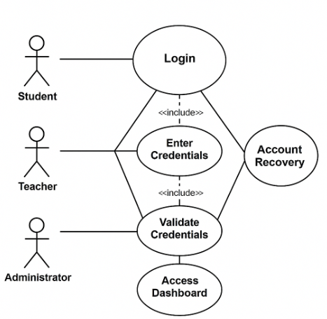
Figure 5– School System Login

Sequence Diagram
The Sequence Diagram illustrates the step-by-step interaction between a user and the system during the login process. Figure 2 shows how the user inputs credentials, how the system validates them, and what happens based on the result.
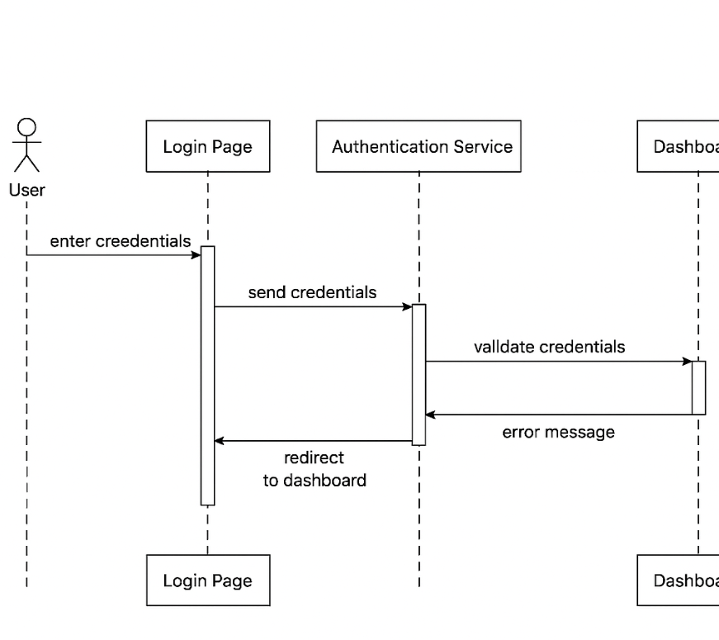
Figure 6 Sequence Diagram – User Login

Activity Diagram
The Activity Diagram represents the flow of actions during the login process. It includes steps like entering credentials, validation, success/failure paths, and redirection to the appropriate dashboard.

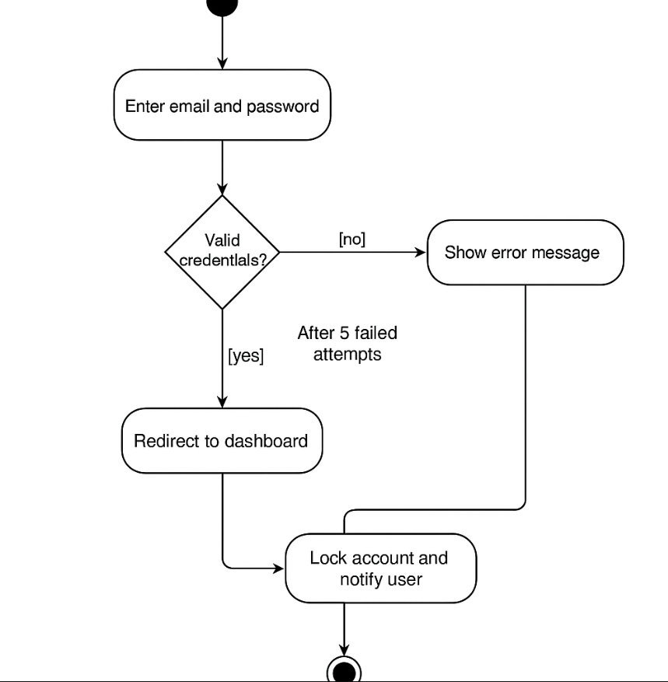
Figure 7 Activity Diagram – Login Process

Class Diagram

The Class Diagram shows the static structure of the login module. It includes classes such as User, LoginManager, and Session, along with their attributes and methods. Relationships between these classes are also illustrated.

Figure 4: Class Diagram – Login Module
(To be inserted: a diagram showing class names, attributes, methods, and associations)

Summary

DESIGN CONSIDERATIONS

Introduction
Design considerations include various elements such as functionality, usability, scalability, performance, maintainability, security, compatibility, and cost. we will create high-quality software that meets the needs of the users, while also meeting the requirements and specifications of the project.

Architectural Strategy
A well-defined architectural strategy is a foundational element of any software system. It encompasses the core components and services that collectively deliver the system’s functionality, performance, and user experience.In a typical application, when a user performs an action (e.g., submitting data), the system processes the input, stores it securely, and provides real-time feedback or updates based on predefined logic and rules. The architecture is commonly structured into three main layers which promotes scalability and maintainability.

Presentation Layer (User Interface Layer):
This is the front-facing part of the system where users interact with the application. It provides an intuitive and responsive interface for performing tasks such as data entry, navigation, and viewing reports or analytics.

Business Logic Layer (Processing and Notifications):
This layer handles the core logic of the application. It processes user inputs, enforces business rules, performs calculations, and triggers system responses such as alerts, validations, or automated actions. It ensures that the application behaves as expected under various conditions.

Data Layer (Storage and Synchronization):
This layer is responsible for storing and managing application data. It ensures data consistency, security, and availability across devices and sessions. It may involve cloud databases, local storage, or hybrid solutions, and supports real-time synchronization when needed.

Development Requirements

Hardware Requirements
Explain the hardware that you will use to develop the project
  - Computer/laptop for development (PC, Acer Laptop).
  - Stable internet connectivity.
  - Development server for testing.
  - Standard peripherals like keyboard, mouse, and monitor.
  - Backup solutions for data protection.

Software Requirements
To develop the system, the following software components are needed:
- Operating System: Windows 11
- A Server: A web server such as Apache or Nginx is required to manage the application content (XAMPP).
- Back-end development programing languages and frameworks: required for the system development- Backend.
- Lang1
- Lang2
- Lang3
- Frontend programing languages and frameworks: Required for the system development- Frontend
- Lang1
- Lang2
- Lang3

Graphic User Interface Design and wireframe
Show the UI interface design of the product. Also explain the wireframe is how the app or the site move from one page to another.
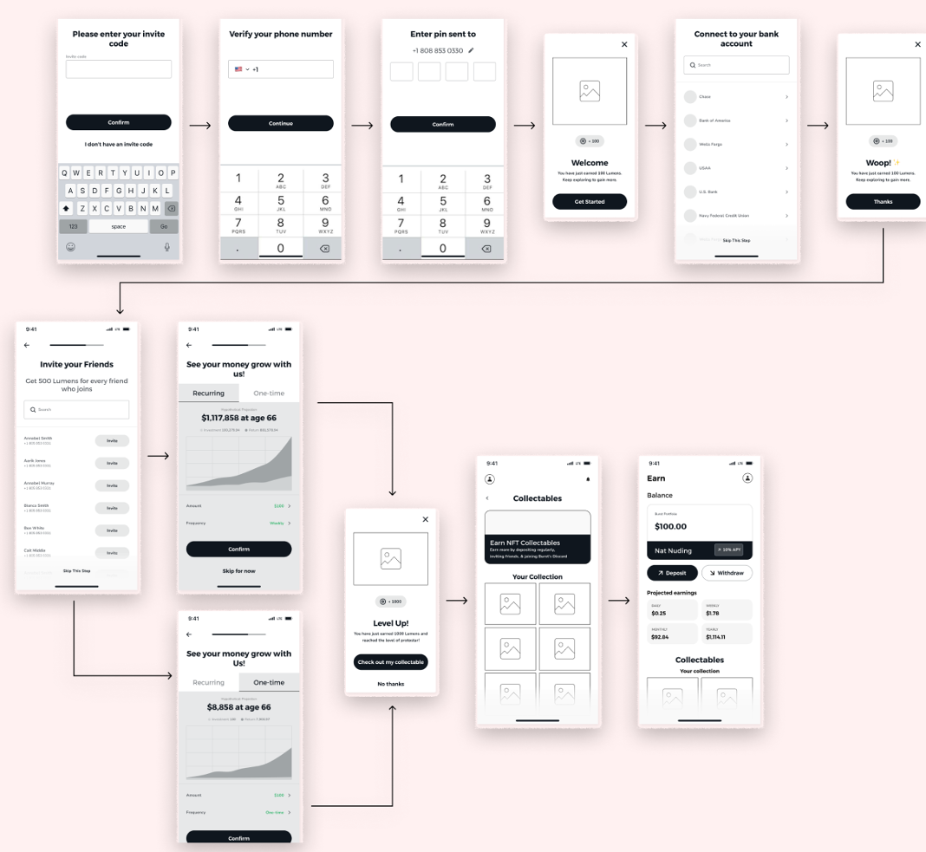

Figure 8 Example of product wireframe and UI

Summary
Summry of the chapter

CONCLUISON

Introdction

This chapter provides a comprehensive overview of our project, highlighting the challenges we encountered, the timeline of our work, and insights into future development. It concludes with a summary of the entire report.

Challenges and learning experiences
Expalin the challenges that your team faced during the project, and what have learnd form this project

Timeline
Illustrate the project time line

Furture work
Here your explain what will your team do In project 2

Conclusion
Provide a full summary of this project report

Reference:
[1] Eleonora Mercier, Stefanie Villeneuve, Mary Mondor, Ilker Uysal, Impact of Food Waste on Society, Specifically at Retail and Foodservice Levels, Foods, 2024.
[2] Food and Agriculture Organization of the United Nations (FAO). Food Loss and Waste Platform. Available at: https://www.fao.org/platform-food-loss-waste/en/
[3] Aung, M. M., & Chang, Y. S. (2014). Temperature management for the quality assurance of a perishable food supply chain. Food Control, 40, 198–207. https://doi.org/10.1016/j.foodcont.2013.11.016
[4] Liu, L., Chen, H., & Yang, H. (2019). Real-time monitoring system for cold chain logistics of perishable food based on wireless sensor networks. Journal of Food Protection, 82(4), 604–611. https://doi.org/10.4315/0362-028X.JFP-18-123
[5] World Bank. Food Loss and Waste. Available at: https://www.worldbank.org/en/topic/food-loss-and-waste
[6] World Health Organization (WHO). Food Safety Fact Sheet. Available at: https://www.who.int/news-room/fact-sheets/detail/food-safety
[7] United Nations. The Sustainable Development Goals Report 2019. Available at: https://unstats.un.org/sdgs/report/2019/
[8] Sensitech. (n.d.). TempTale GEO Ultra: Real-time temperature and location monitoring [PDF].
[9] Sensitech. (n.d.). Real-time temperature monitors. Retrieved from https://www.sensitech.com
[10] Maquimsa. (n.d.). DicksonOne data logger: Temperature, humidity, and differential pressure monitoring [PDF].
[11] Sonicu. (n.d.). Temperature monitoring systems. Retrieved from https://www.sonicu.com/temperature-monitoring
[12] Cooltrax. (n.d.). Cold chain monitoring solutions. Retrieved from https://cooltrax.com/
[13] Dickson. (n.d.). DicksonOne: Environmental monitoring solution. Retrieved from https://www.dicksonone.com/

